# CS 255 System Design Document

Christopher Barnes

## UML Diagrams

### UML Use Case Diagram

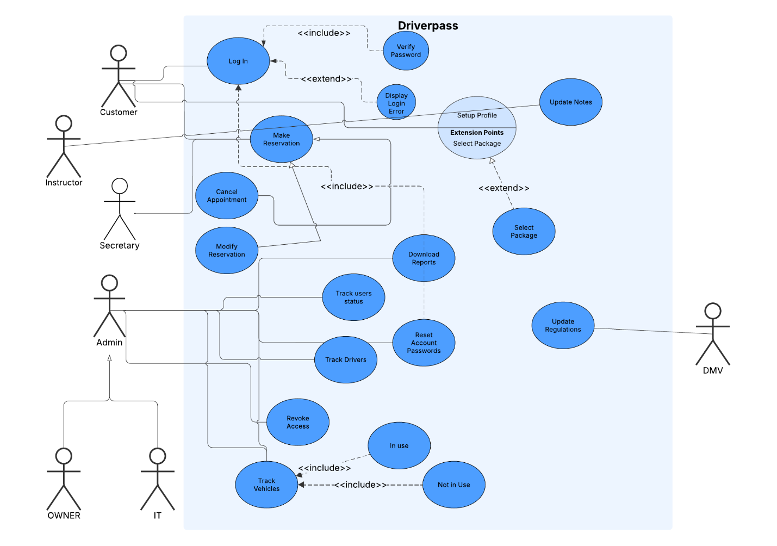

### UML Activity Diagrams

*1 -- 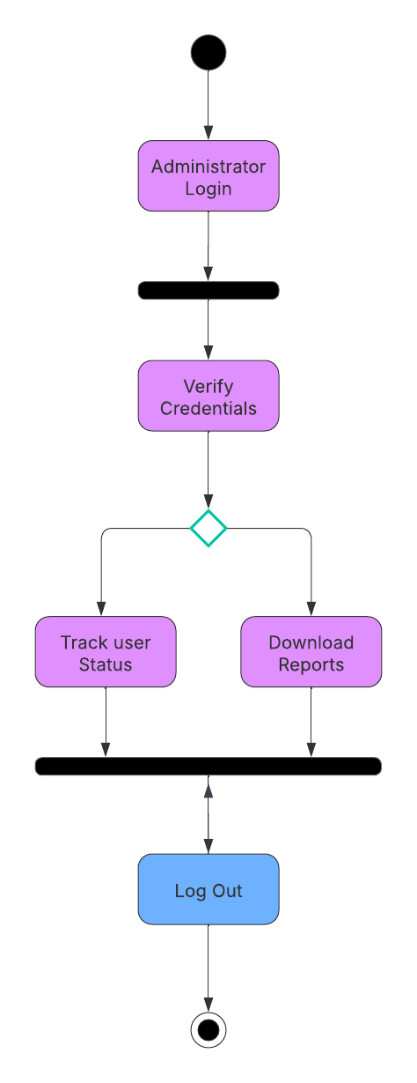2 --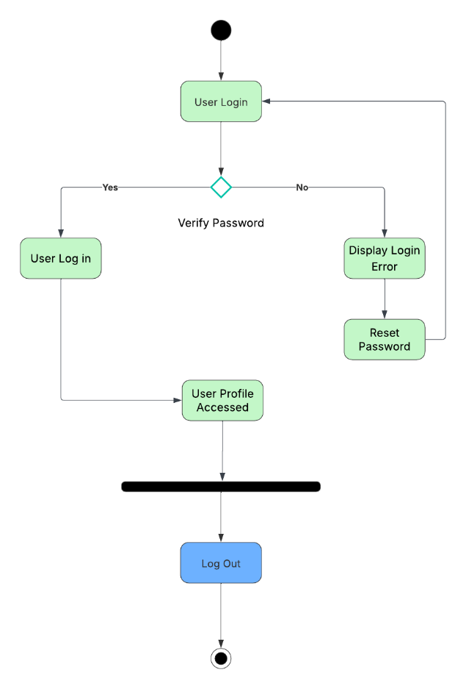*

### UML Sequence Diagram

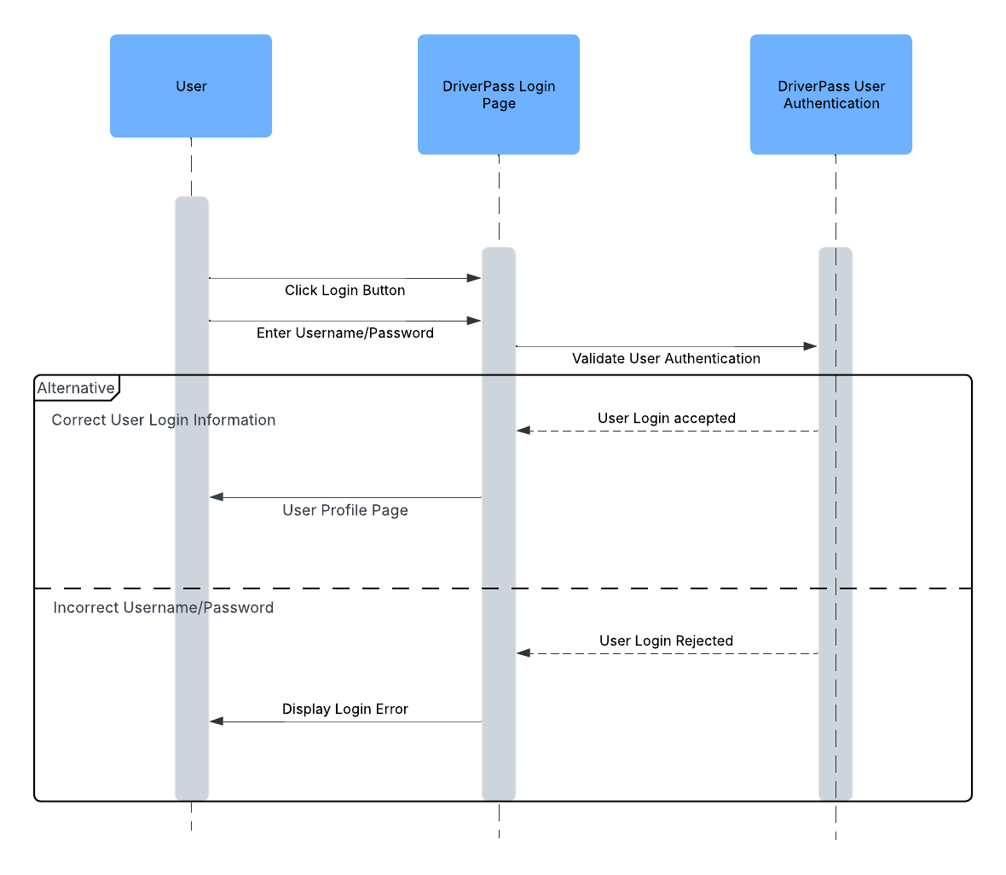

### UML Class Diagram

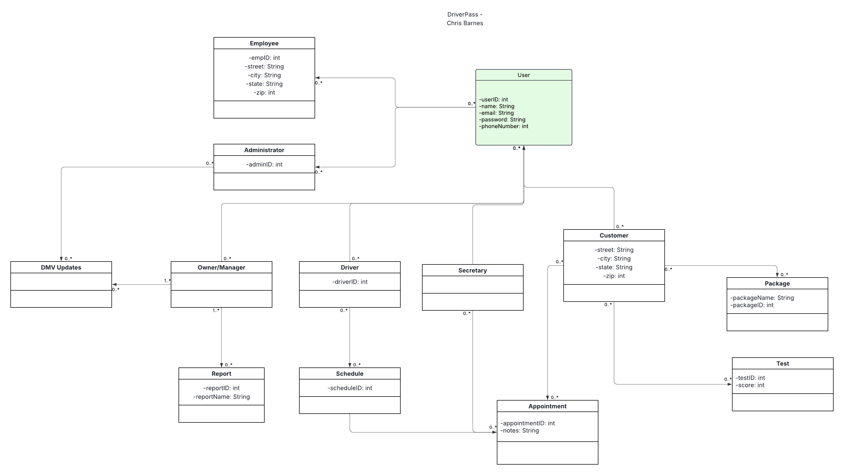

## Technical Requirements

* *Hardware:*
  + *Internet Connection*
  + *Phone/Mobile Device*
  + *Monitor*
  + *Computer*
  + *Router*
  + *Modem*
  + *Keyboard*
  + *Mouse*
  + *Cars*
  + *GPS Tracking devices*
  + *Security Cameras for office*
  + *Security Cameras for cars*
* *Software:*
  + *Reports - Microsoft Excel/Google Sheets/Apple Numbers*
  + *Virus Protection*
  + *GPS software*
  + *Audio Visual Software for cameras*
* *Infrastructure:*
  + *Multi-user Authentication*
  + *Firewall*
  + *Cloud-based webserver*
  + *Online Database*
  + *Login/Landing Page*
  + *User Interface*
  + *DMV Information*